1. Write a Python program to calculate the area of a rectangle given its length and width. 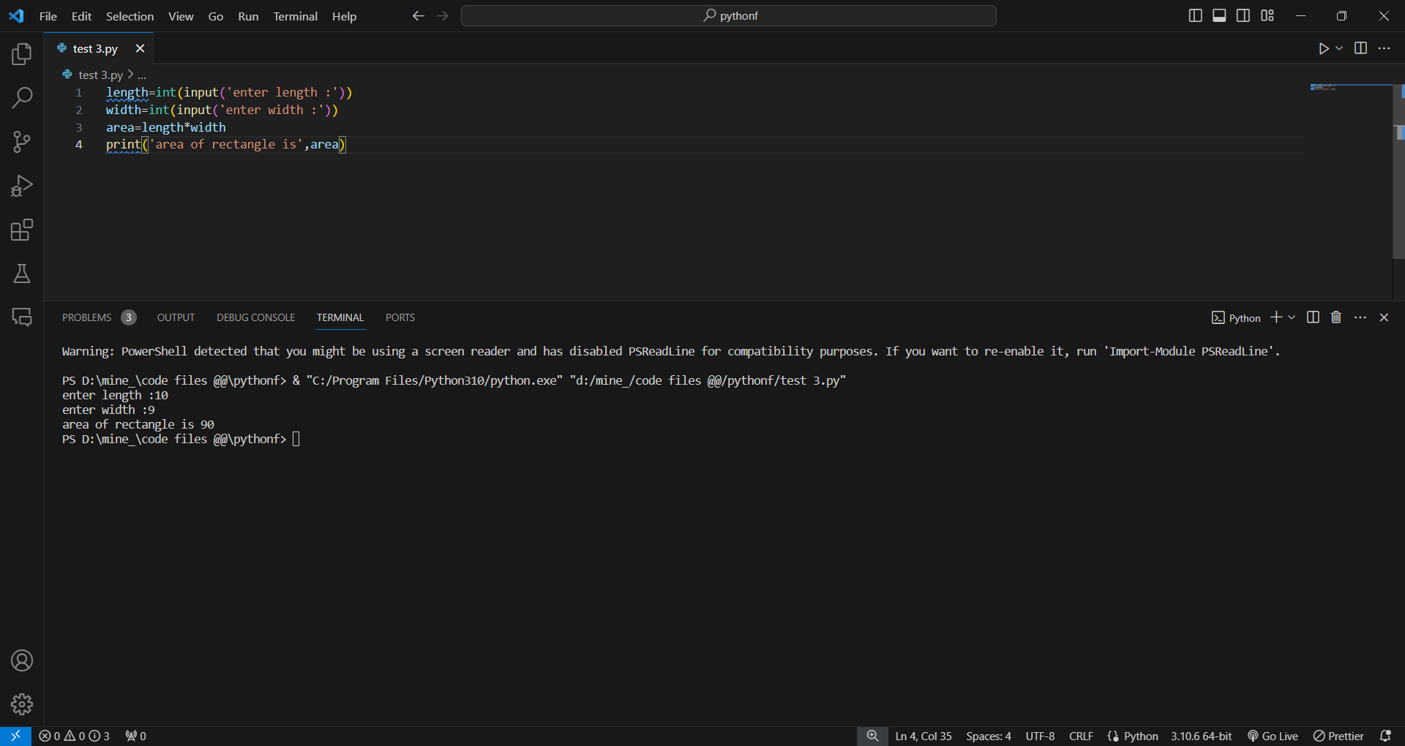

2. Write a program to convert miles to kilometers 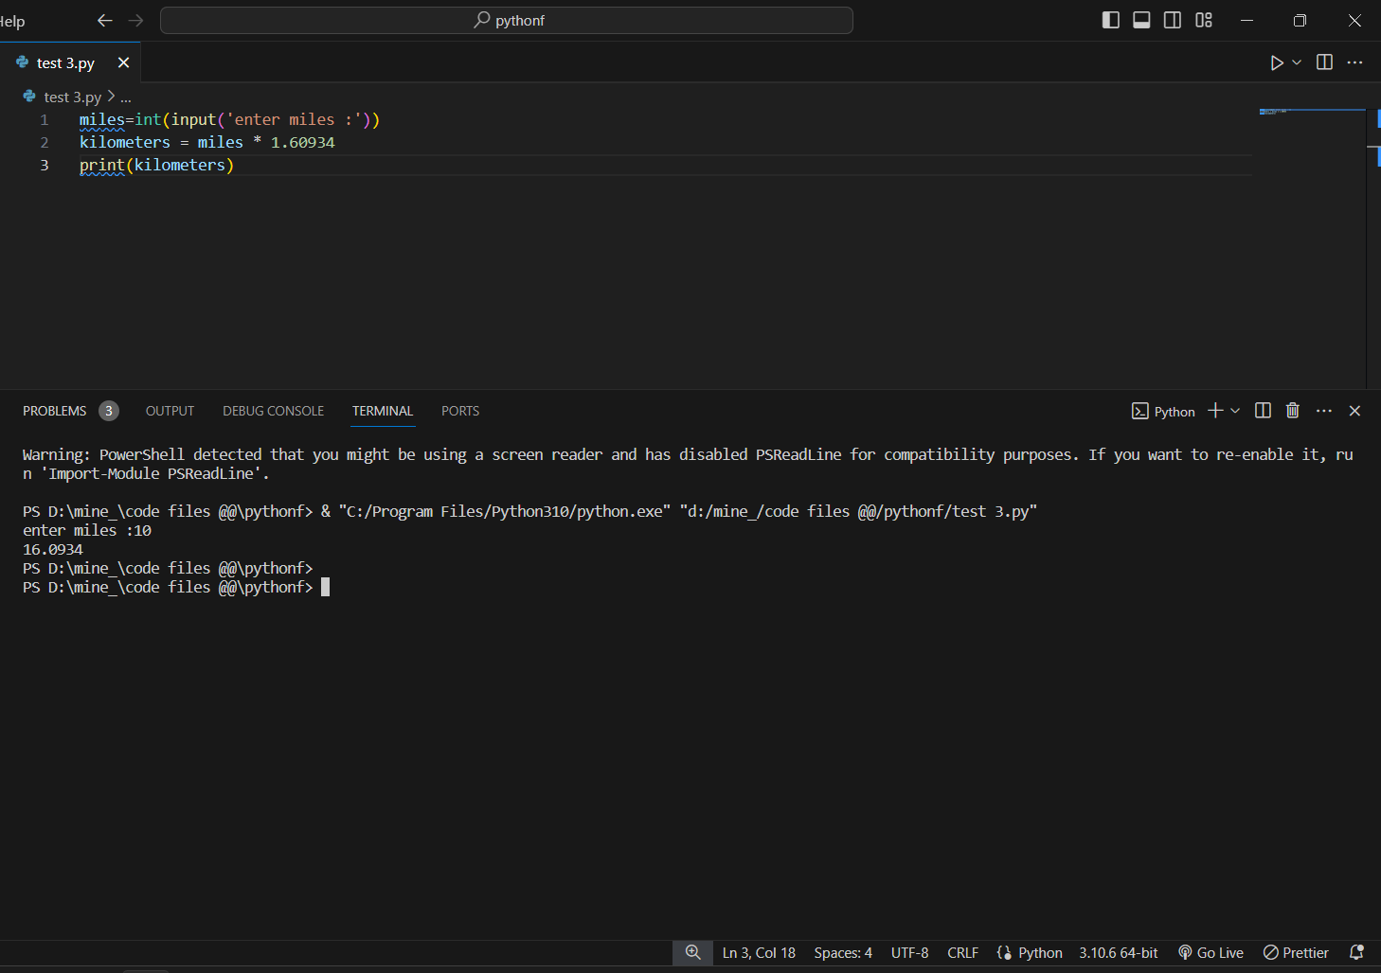

3. Write a function to check if a given string is a palindrome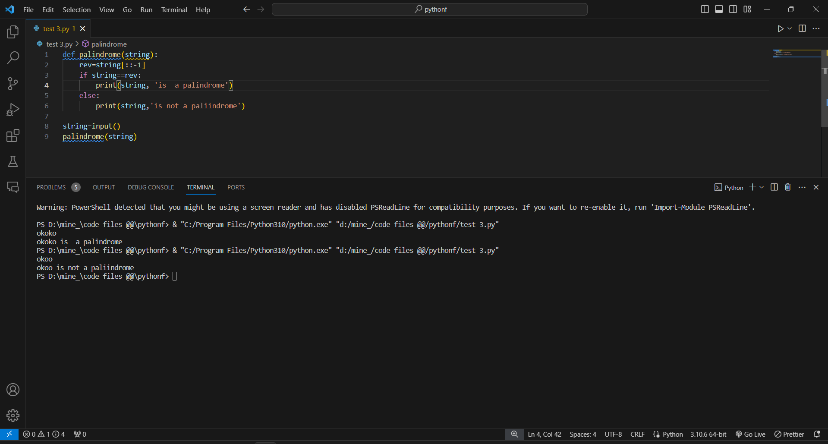.

4. Write a Python program to find the second largest element in a list. 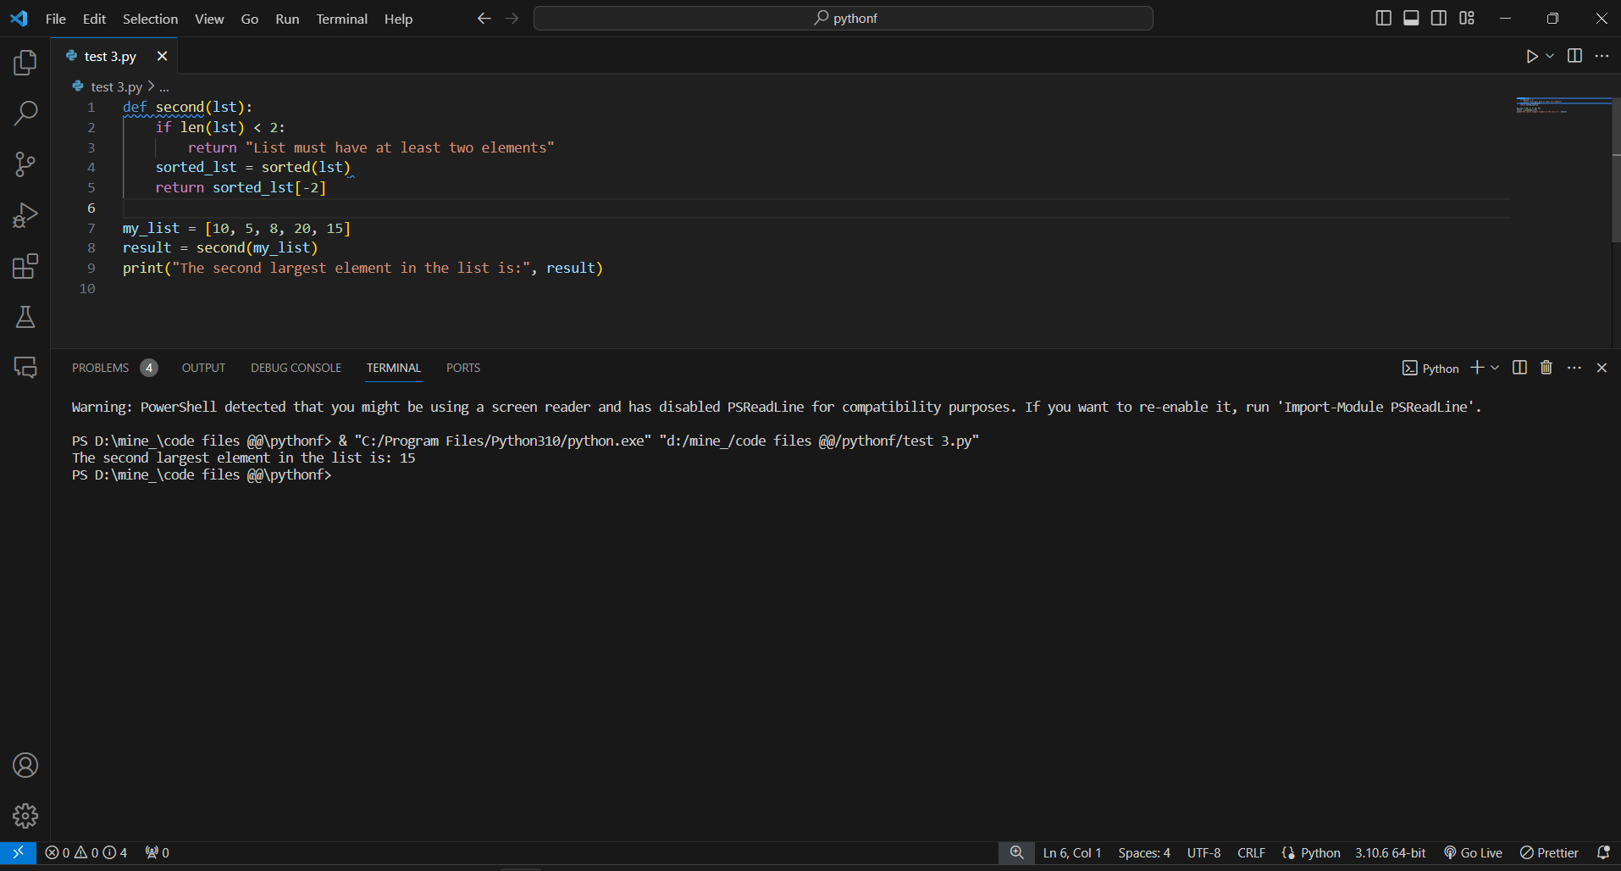

5. Explain what indentation means in Python.

Ans: Indentation is a space used to represent the block of code or statements in python. In the other programming languages like c,c++,java we use the { } curly braces to represent the block of code

for example :

for i in range(10):

print(i)

6. Write a program to perform set difference operation. 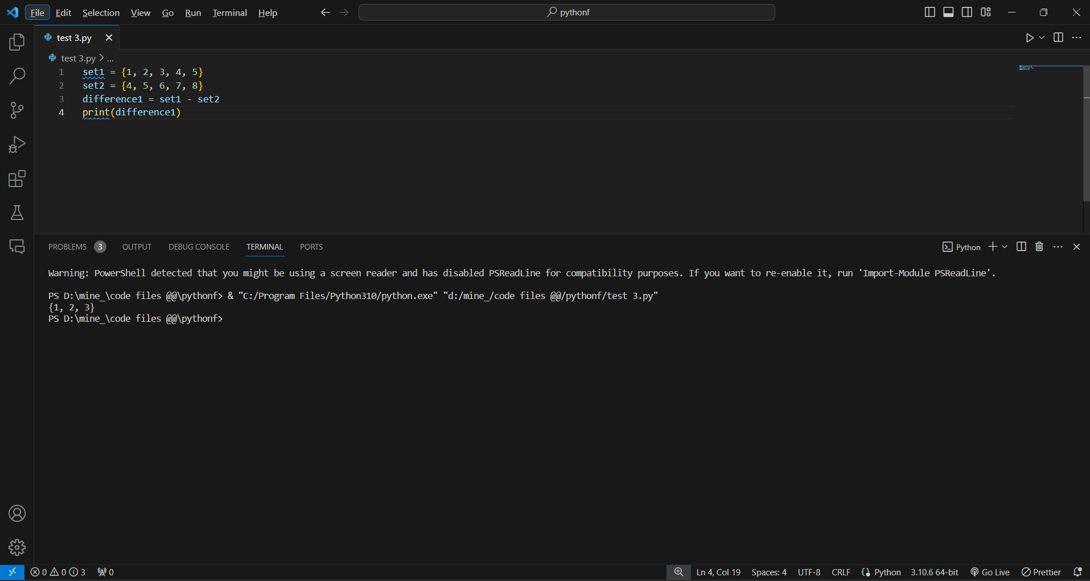

7. Write a Python program to print numbers from 1 to 10 using a while loop. 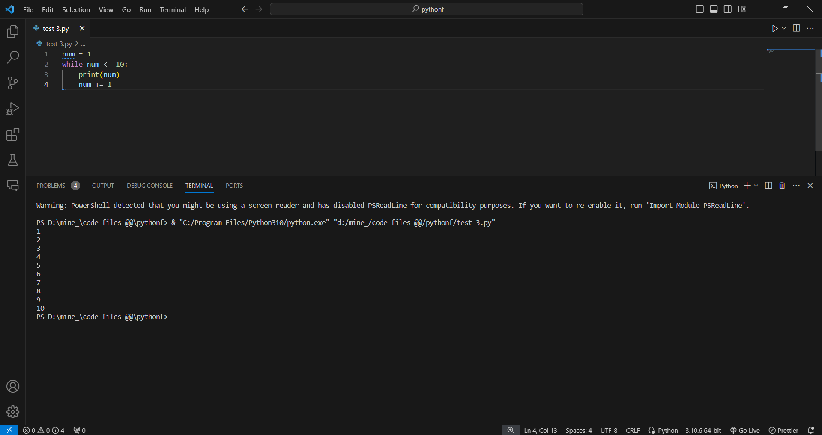

8. Write a program to calculate the factorial of a number using a while loop. 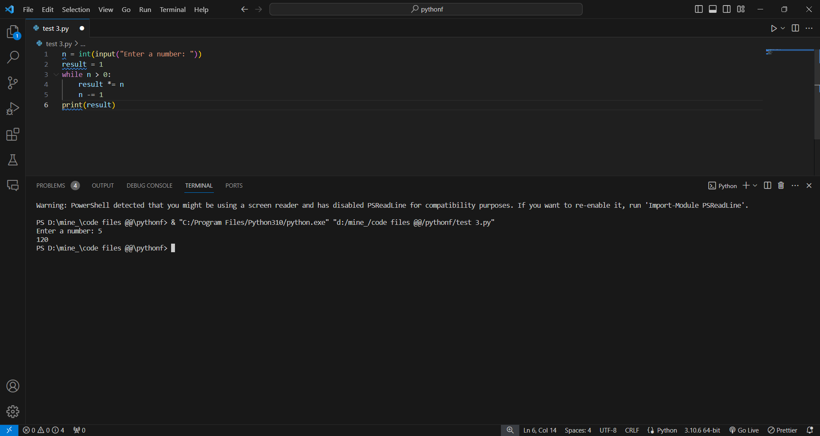

9. Write a Python program to check if a number is positive, negative, or zero using if-elif-else statements. 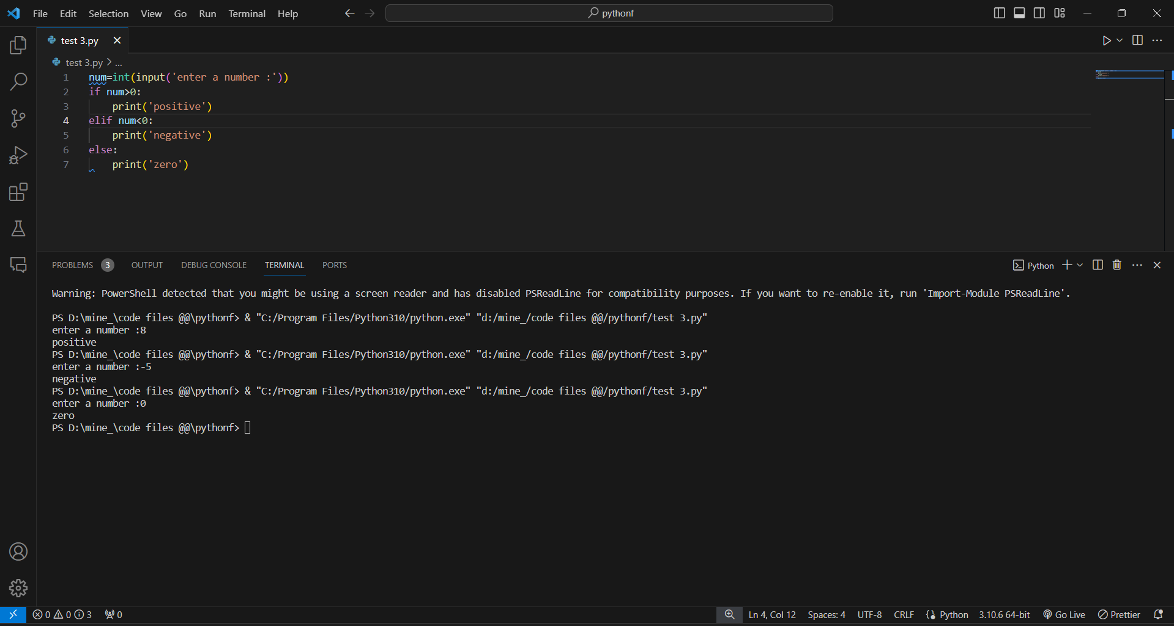

10. Write a program to determine the largest among three numbers using conditional statements. 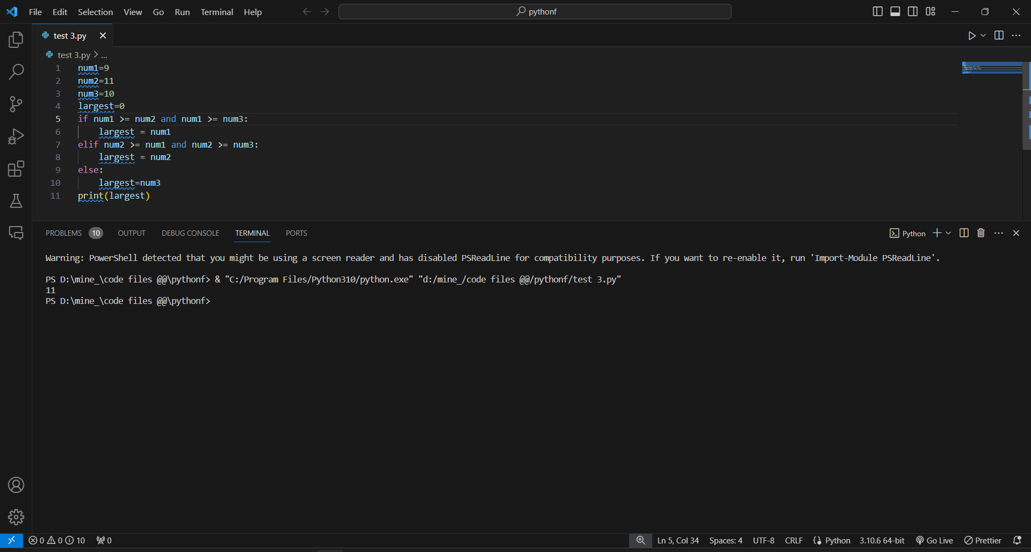

11. Write a Python program to create a numpy array filled with ones of given shape. 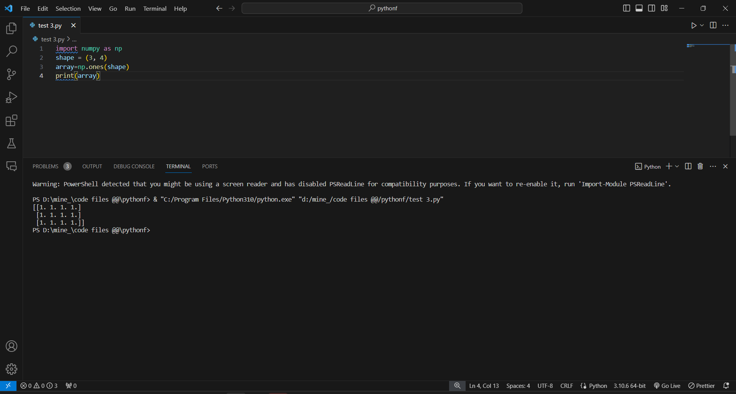

12. Write a program to create a 2D numpy array initialized with random integers. 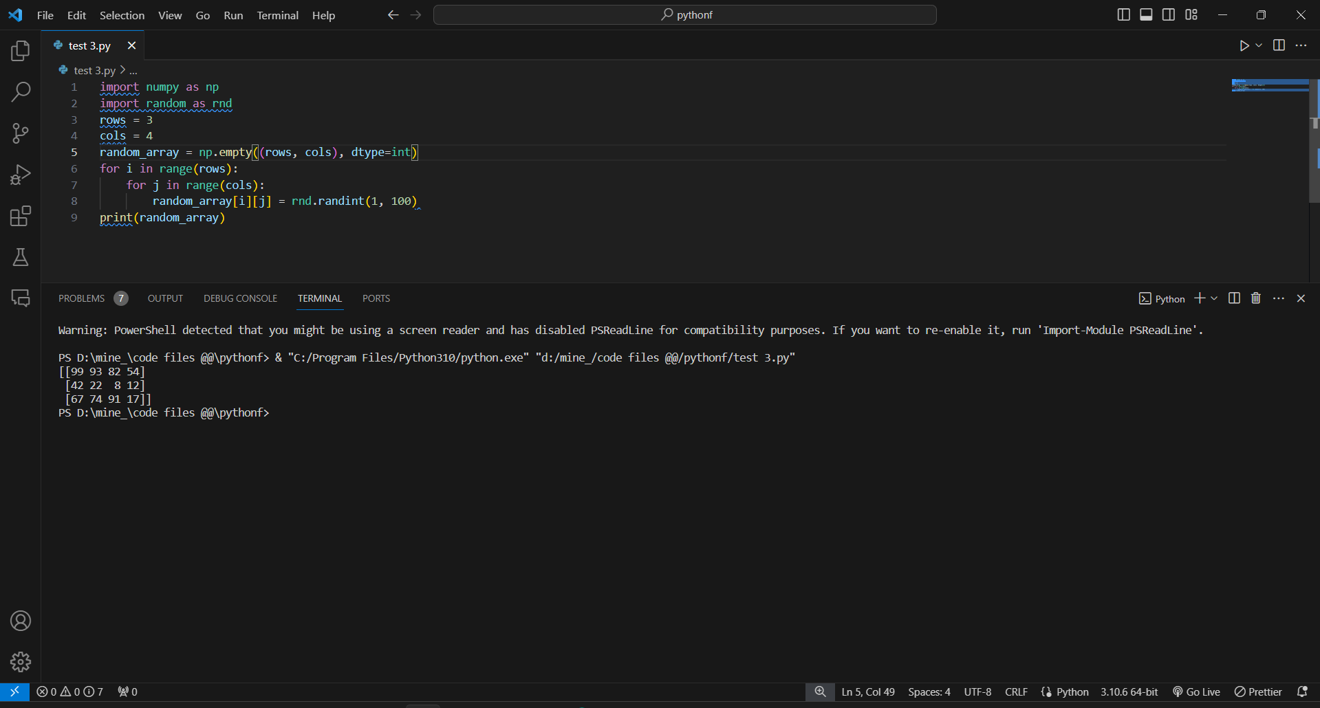

13. Write a Python program to generate an array of evenly spaced numbers over a specified range using linspace. 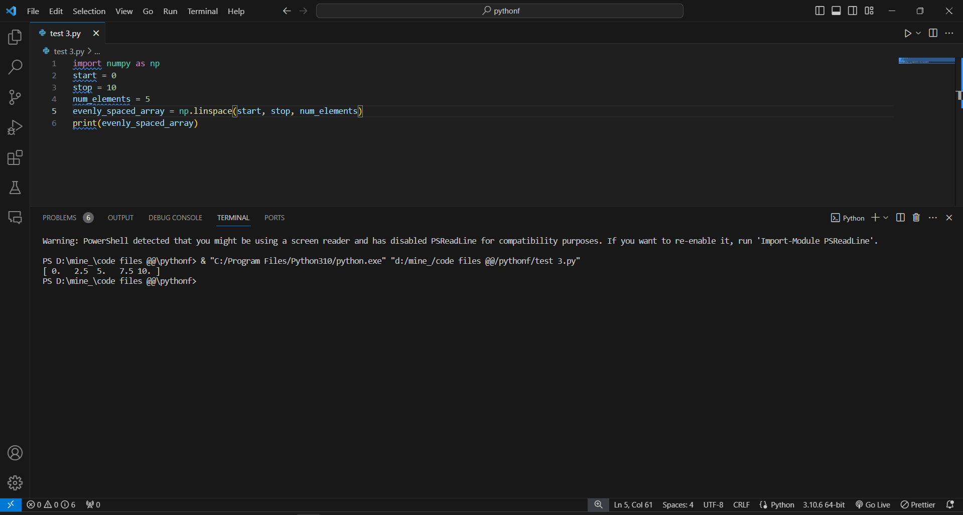

14. Write a program to generate an array of 10 equally spaced values between 1 and 100 using linspace. 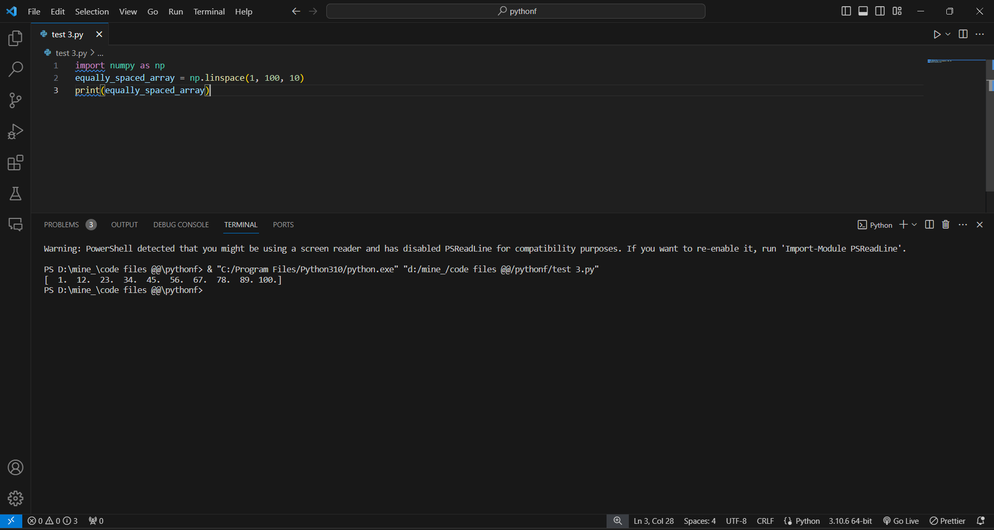

15. Write a Python program to create an array containing even numbers from 2 to 20 using arange. 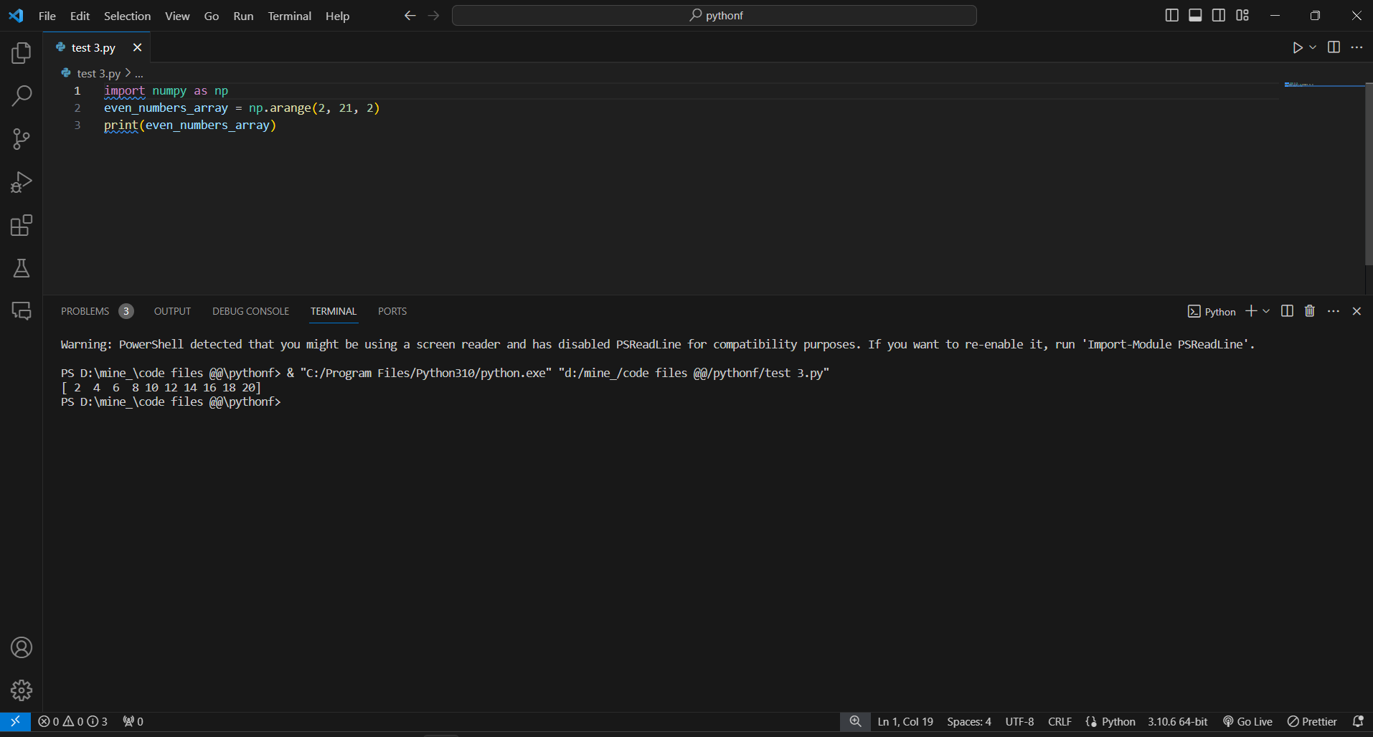

16. Write a program to create an array containing numbers from 1 to 10 with a step size of 0.5 using arange. 